**Python Exercises Week 5**

Complete each exercise as it own separate.py file named after the exercise number. For example, ***exercise_1.py***

Zip all exercise files in one folder named ***last_name_exercise_week_5.zip and submit to the appropriate drop box.***

1. Write a program that asks a user for a number. The program should generate random numbers based on the user input, each in the range of 0 through 9. Assign each number to a list element, then write another loop that displays the contents of the list.

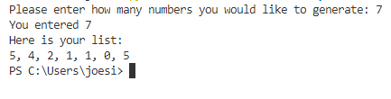

1. Write a program that creates a two-dimensional list with 5 rows and 3 columns based off user input. Then write nested loops that get an integer value from the user for each element in the list.

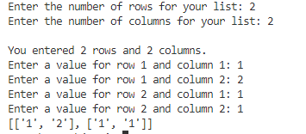

1. Write a program that reads an unspecified number of scores and determines how many scores are above or equal to the average and how many scores are below the average. Assume the input numbers are separated by one space in one line.

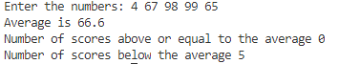

1. Write a program that reads in numbers separated by a space in one line and displays distinct numbers (i.e., if a number appears multiple times, it is displayed only once). (Hint: Read all the numbers and store them in a list. Create another list. Add a number in the fist list to the second list but if the number is already in the second list, ignore it.)

**General Programming Exercise (not specific to lists)**

1. Suppose you have a certain amount of money in a savings account that earns compound monthly interest, and you want to calculate the amount that you will have after a specific number of months. The formula is as follows:

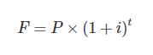

The terms in the formula are:

* F is the future value of the account after the specified time period.
* P is the present value of the account.
* i is the monthly interest rate.
* t is the number of months.

Write a program that prompts the user to enter the account’s present value, monthly interest rate, and the number of months that the money will be left in the account. The program should pass these values to a function that returns the future value of the account, after the specified number of months. The program should display the account’s future value

